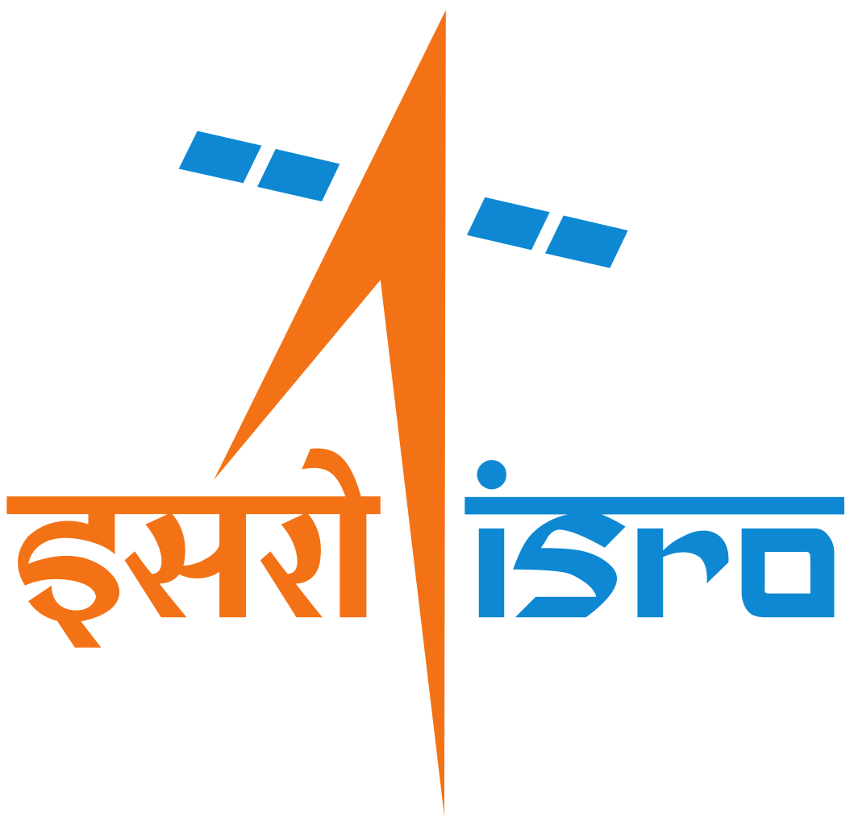

**ABOUT ISRO:**

The Indian Space Research Organisation (ISRO) is the space agency of the Government of India, established in 1969. It is responsible for the development and deployment of India's space programs and satellite missions. ISRO has made significant strides in space technology and exploration, including launching numerous satellites for communication, Earth observation, and scientific research. Notable achievements include the Mars Orbiter Mission (Mangalyaan) in 2013 and the Chandrayaan missions to the Moon. ISRO's cost-effective and innovative approach to space exploration has gained global recognition, and it continues to contribute to India's technological advancement and international collaborations in space science and research.

**Title: Product Dissection Project for ISRO**

Creating a product dissection project for ISRO (Indian Space Research Organisation) would involve an in-depth analysis of ISRO's products and technologies used in space missions. To begin, let's outline the project and its objectives:

# **Project Overview:**

The Product Dissection Project for ISRO aims to provide a comprehensive understanding of ISRO's space products and technologies, including satellites, spacecraft components, launch vehicles, and ground station equipment. This project will involve dissecting and analyzing various components of these products to gain insights into their design, functionality, and technology.

# **Project Objectives:**

1. **Gain In-Depth Knowledge:** Dissect ISRO's products to understand their internal components, materials used, and how they function.

**2. Identify Areas of Improvement:** Identify areas where product design or materials can be optimized to enhance performance and reliability.

**3. Foster Innovation:** Use insights from dissection to promote innovation in materials, manufacturing processes, and technology used in space missions.

**4. Educational Value:** Create a repository of dissection data that can be used for educational purposes, training programs, and knowledge sharing within ISRO.

**Methodology:**

# The dissection process will follow a systematic approach:

**1. Preparation:**

- Selection of specific ISRO products and components to dissect, based on project goals.

- Formation of a multidisciplinary dissection team, including engineers, technicians, and researchers.

**2. Dissection Process:**

- Detailed examination of product blueprints, technical documentation, and specifications.

- Physical dissection of selected components, carefully documenting each step.

- Utilization of advanced tools and equipment for non-destructive testing and analysis.

**3. Documentation:**

- Recording of observations, measurements, material properties, and component specifications.

- Capturing images, videos, and 3D models for reference and in-depth analysis.

- Compilation of a comprehensive dissection report for each dissected component, including findings, recommendations, and lessons learned.

**Data Storage and Management:**

- Dissection data, including observations, measurements, images, videos, and reports, will be securely stored in a centralized database.

- Data will be organized by product types and specific components to facilitate easy retrieval and analysis.

- Access controls will be implemented to ensure data security and compliance with privacy regulations.

# **Benefits and Outcomes:**

**- Knowledge Enhancement:** Engineers and researchers will gain a profound understanding of ISRO's products and technology.

**- Innovation:**Insights from dissection activities will often lead to innovations in materials, manufacturing processes, and technology used in space missions.

**- Quality Improvement:** Findings will contribute to improving the quality, reliability, and performance of ISRO's space products.

**- Educational Value:** The data generated from dissection will serve as valuable educational material for training programs, workshops, and knowledge sharing within ISRO.

# 

# **Conclusion:**

The Product Dissection Project for ISRO is a crucial initiative aimed at enhancing knowledge, fostering innovation, and improving the quality and reliability of space products used in ISRO's missions. It also serves as an educational resource, promoting continuous learning and knowledge sharing within the organization.

This project will require meticulous planning, skilled professionals, and state-of-the-art equipment to carry out the dissection process and manage the resulting data effectively.

Creating an ER (Entity-Relationship) diagram and database schema for ISRO's Product Dissection Project would involve defining entities, their attributes, and relationships to represent the project's data structure. Here's a simplified representation:

Entity-Relationship Diagram (ERD):

**Entities:**

**1. Product:**

**Attributes:** ProductID (INT,Primary Key),

ProductName(VARCHAR),

Description(TEXT),

Manufacturer(VARCHAR)

YearOfManufacture(INT)

**2. Component:**

**Attributes:**ComponentID( INT (PRIMARY KEY))

ComponentName( VARCHAR(255)),

Description (TEXT),

Material( VARCHAR(255)),

Functionality (TEXT)

**3. Engineer:**

**Attributes:** EngineerID (Primary Key),

Name(VARCHAR,255),

Designation(VARCHAR,255),

Specialization(VARCHAR,255)

**4. DissectionRecord:**

**Attributes:** RecordID (INT,Primary Key),

EngineerID (INT,Foreign Key),

ProductID (INT,Foreign Key),

ComponentID (INT,Foreign Key),

DissectionDate(DATE),

Observations(TEXT)

# 

# **Relationships:**

- A Product can have multiple Components (1 to many relationship).

- Engineers are involved in multiple Dissection Records (many to many relationship).

- Dissection Records document observations and insights during dissection.

# 

# Database Schema:

This schema allows you to store data related to the Product Dissection Project, including details about products, components, engineers, and records of dissections. The relationships between these entities are established through foreign key constraints.

**REAL WORLD SCENARIO:**

let's explore a real-world scenario for ISRO's Product Dissection Project, which involves dissecting and analyzing space products and technologies to gain valuable insights and improve their performance and reliability.

# **Project Overview:**

ISRO, the Indian Space Research Organisation, is renowned for its space missions and satellite deployments. To maintain and enhance the quality and reliability of their satellites and spacecraft, ISRO initiates the "Satellite Component Dissection and Analysis Project." This project aims to dissect and analyze the key components of satellites and spacecraft, such as communication payloads, propulsion systems, and solar panels.

**Objectives:**

**1. In-Depth Understanding:** Gain a comprehensive understanding of the internal components, materials, and technology used in ISRO's satellites and spacecraft.

**2. Quality Enhancement:** Identify opportunities for optimizing component design and materials to improve overall performance and reliability.

**3. Innovation:**Utilize insights from the dissection process to foster innovation in materials, manufacturing processes, and technology used in future space missions.

**4. Knowledge Dissemination:** Create a repository of dissection data for educational purposes, internal training programs, and knowledge sharing within ISRO.

Methodology:

**Preparation:**

- A specialized team of engineers, technicians, and researchers is assembled for the project.

- A set of satellites and spacecraft components are selected for dissection based on their relevance to ongoing or future missions.

**Dissection Process:**

- A dedicated dissection facility is set up with advanced equipment and tools.

- The selected components are meticulously dissected, and each step is carefully documented.

- Non-destructive testing and analysis techniques are employed to ensure minimal damage to the components.

**Documentation:**

- Observations, measurements, material properties, and component specifications are thoroughly documented.

- High-resolution images, videos, and 3D models are captured for reference and in-depth analysis.

- Comprehensive dissection reports are created for each dissected component, containing findings, recommendations, and lessons learned.

**Data Storage and Management:**

- Dissection data, including observations, measurements, images, videos, and reports, are securely stored in a centralized database.

- The database is organized by satellite or spacecraft models and specific components, making data retrieval and analysis efficient.

- Strict access controls are implemented to ensure data security and compliance with privacy regulations.

**Benefits and Outcomes:**

**- Improved Design:** Insights from the dissection process lead to improved component design and reliability.

**- Innovations:** Innovations in materials and manufacturing processes enhance future space missions.

**- Educational Value:** Dissection data serves as invaluable educational material for internal training programs and knowledge sharing within ISRO.

This real-world scenario showcases how ISRO's Satellite Component Dissection and Analysis Project contributes to the organization's continuous improvement, innovation, and knowledge dissemination while ensuring the reliability and success of its space missions.